
To: WV STARS Professional Development (PD) Providers
From: WV STARS
Date: July 21, 2025
Re: Update to Scheduled Event Start/End Date Registration Options and Reminders

Hello WV STARS PD Providers!
Here are a few updates and reminders:
- There has been an update to what participants are able to see on the Training Calendar regarding start and end dates/times in an event’s registration settings.

You can find this setting under the “Edit Schedule” section of a scheduled event:
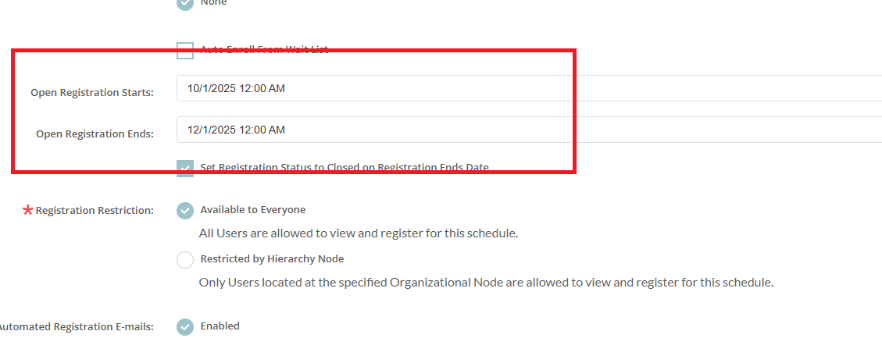

Previously, the date/time entered for either “Open Registration Starts” or “Open Registration Ends” meant someone couldn’t see the event (or register) before the start date/time or after the end date/time. Now, participants are able to see the event on the public training calendar when you put it on the Manage Learning > Manage Scheduled Events training calendar, and the dates/times entered in these two fields are the start/end dates/times for registration.

If someone tries to register, they will not see the registration button. Instead, they will be notified of the dates/times when registration will open and close (as seen below):
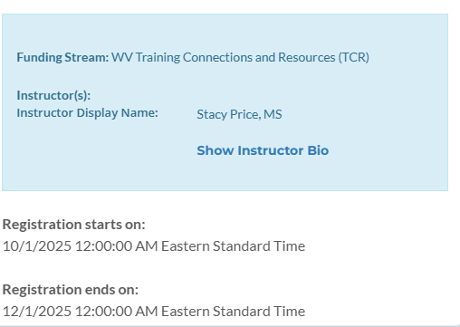
Please keep this in mind as you add your scheduled events to the training calendar.

- When creating courses, remember to keep Learning Outcomes for your course in mind. With the goal of improving the quality of training, it is good practice to include your Learning Outcomes when you submit a new course, in addition to the normal training registration requirements. Please refer to the “WV STARS Foundations of Learning Outcomes and Assessments” training course if you need more information. There is a FAQ that talks about the difference between Course Objectives vs. Learning Outcomes here.

- Please make sure to include the necessary information for every scheduled event in your Agenda (this includes a Proof of Learning for all online trainings). For a review of what to include in your agenda, please refer to the FAQ found here. For information about the Proof of Learning, please refer to the FAQ here.

- When you submit a new course for approval, you can check the status of it at any time. You should receive an email once it is submitted for approval and/or if rejected, but you don’t receive an email when it is approved (this email will go to the course owner’s email found on their registry account and is automated). To check the status of the course, please refer to the FAQ found here.

Please contact me with any questions regarding this information.

Thank you,

Stacy Price, MS  WV STARS Professional Development Specialist  WV State Training and Registry System (WV STARS)  www.wvstars.org  www.facebook.com/wvstars | 611 Seventh Avenue, Suite 322  Huntington, WV 25701  T: 304-522-7827 x3471  F: 304-529-2535  sprice@rvcds.org

Administered by WV Early Childhood Training Connections and Resources, a program of River Valley Child Development Services “Serving Children and Families since 1971”
This program is being presented with financial assistance as a grant from the West Virginia Department of Health and the West Virginia Department of Human Services and is administered by West Virginia Early Childhood Training Connections and Resources, a program of River Valley Child Development Services.

